Names: ISHIMWE Amos

ID: 26247

Assignment1 introduction to linux

1. If you are in the P3 directory, write the command go to your home (4 marks)

1. using a relative path : cd../../../../..

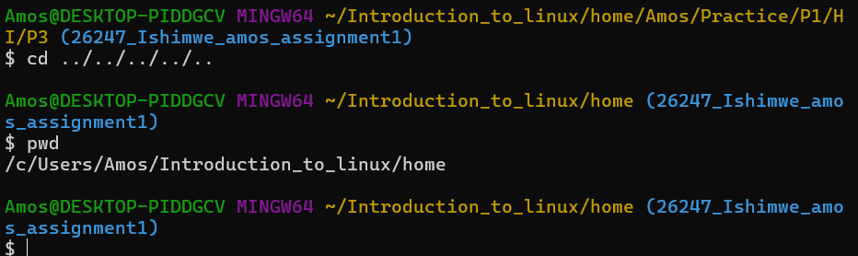

2. using an absolute path: /c/users/Amos/Introduction_to_linux/home

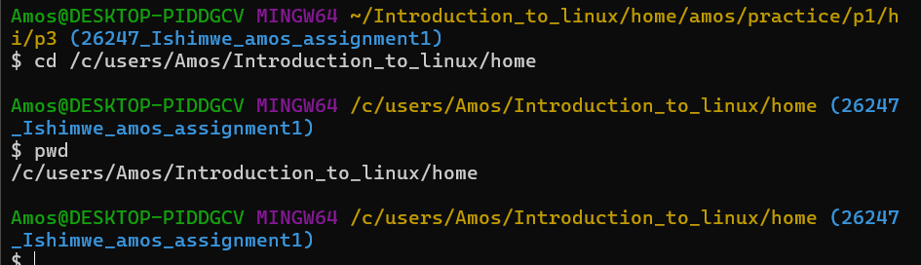

2. Write the command show a long listing of Here (4 marks)

1. using a relative path if you are in the Command directory: ls -l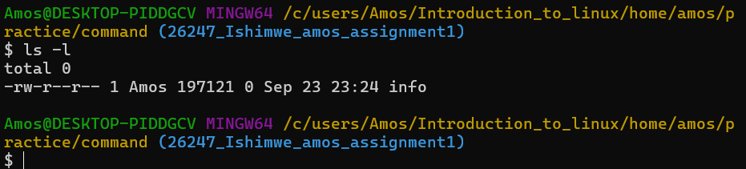

2. using an absolute path ls -l /c/users/Amos/Introduction_to_linux/home/amos/practice/command

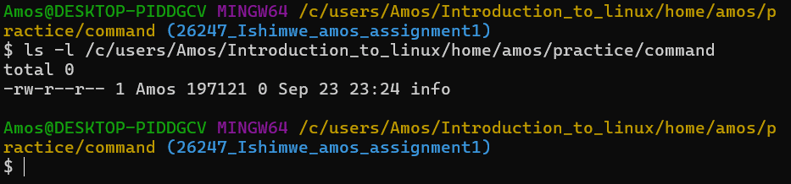

3. Write the command to copy the file P3 to the Command directory? (4 marks)

a. using a relative path if you are in the P2 directory cp -r ../Hi/p3 ../../command/ 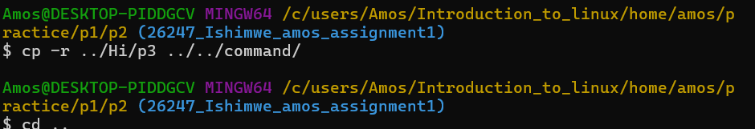

b. using a relative path if you are in the P3 directory: cp -r . ../../command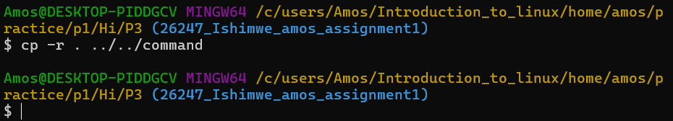

c. using a relative path if you are in the Command directory : cp -r ../P1/Hi/P3 .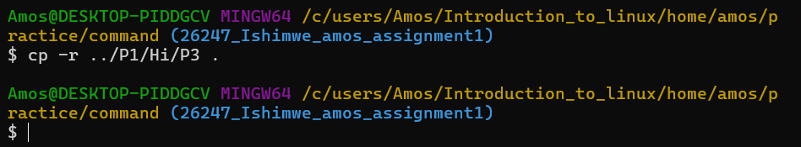

d. using an absolute path: cp -r /c/users/Amos/Introduction_to_linux/home/amos/practice/P1/Hi/P3 /c/users/Amos/Introduction_to_linux/home/amos/practice/command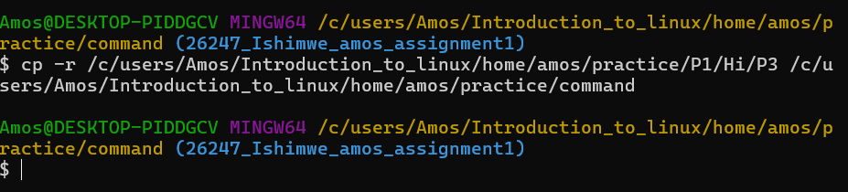

4. Write the command to copy the files in P3 to the Command directory? (4 marks)

a. using a relative path if you are in the P2 directory : cp -r ../Hi/p3/* ../../command/ 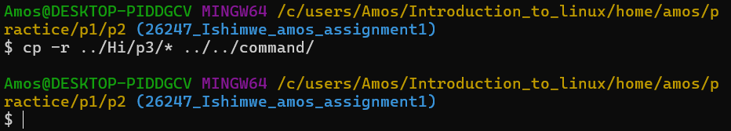

b. using a relative path if you are in the P3 directory : cp -r * ../../command/ 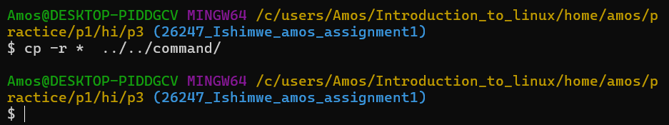

c. using a relative path if you are in the Command directory : cp -r ../P1/Hi/P3/* .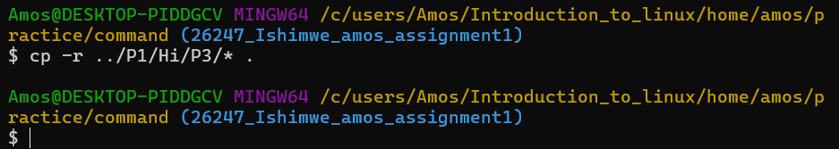

d. using an absolute path cp -r /c/users/Amos/Introduction_to_linux/home/amos/practice/P1/Hi/P3/* /c

/users/Amos/Introduction_to_linux/home/amos/practice/command 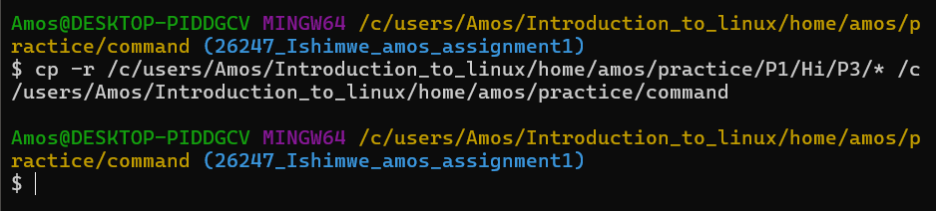

5. What's the difference between these last 2 (Questions 3 and 4)? (2 marks)

Difference between relative path and absolute path

Relative path : The path depends on your current working directory. You use .. (parent), . (current), or subfolder names relative to where you are.

Absolute path : The path starts from the root directory / and gives the full location of the file or folder. It works no matter where you are in the system.

6. What do you think the yellow color means? The blue? What color should hereWeAre be,

and why? (2 marks)

What the colors mean (in Linux/Unix terminal with ls --color)

Yellow (light brown/gold): usually means an executable file (like a program or script you can run).

Blue: means a directory (folder).

hereWeAre: should be blue, because it is a directory (not an executable file)